SIGOMA Submission to the 2023 Autumn Statement
- About SIGOMA

  - SIGOMA represents metropolitan and unitary authorities outside London, from the Southern Ports, the East Midlands, West Midlands, North West, North East and Yorkshire & Humber. The 47 SIGOMA councils are home to 6.3 million households, a quarter of the English total and higher than the number of households of Scotland, Wales and Northern Ireland combined.

1.2 We represent large urban cities and many of the surrounding towns. Our authorities typically represent areas that have suffered most during post-industrial decline and benefitted least from the policy of linking funding to local prosperity. Whilst funding has fallen by 20% in real terms since 2010 for all local authorities, the fall for our members is much greater, -25%, meaning that other councils experienced a cut of 19%

1.3 Deprivation continues to blight the prospects of many of our authorities. 43 of our 47 authorities are in the lower half of Governments’ 2019 Index of Multiple Deprivation (IMD) ranking, with 12 in the most deprived decile of 15 authorities. SIGOMA members make up 75% of the 2 most deprived deciles.

1.4 Most SIGOMA authorities have become relatively more deprived since the last IMD measure in 2015, as shown in the chart below.

SIGOMA Councils Deprivation Ranking 2019 and 2015 (1 is most deprived)
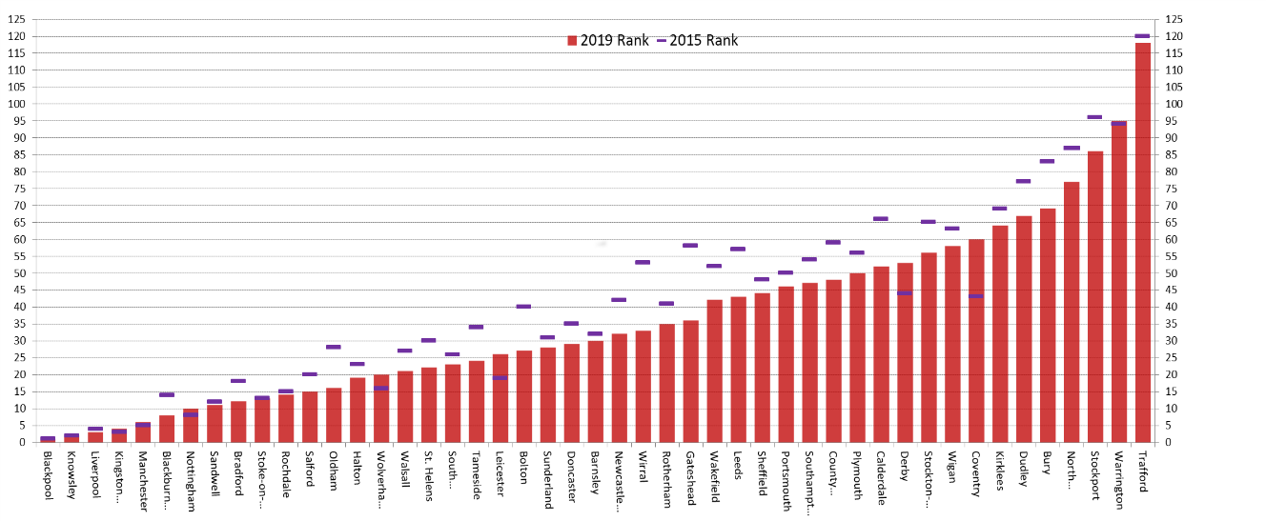
1.5 Whilst this worsening in deprivation ranking is due in part to worse IMD scores of SIGOMA councils, it is also partly due to the improved IMD scores in most other English councils, adding to the “left behind” impact on our members.
1.6 As funding for authority services has fallen since 2010, reliance of residents on vital local services has increased due to austerity. There is a strong, pervasive and well documented link between deprivation and the demand for (and cost of delivering) services by local authorities. Our members have worse outcomes in health, education and employment.

1.7 SIGOMA councils, like all upper tier councils, have been held back from the brink of failure by successive one-off adult social care additional funding grants and the ability to raise an adult social care precept. However we are starting from a lower, weaker tax base and generally benefit less from funding which is earned relative to local taxes such as business rates and Council Tax. Whilst additional funding is always welcome, a lack of certainty and weak funding base, increasingly unrelated to need, is undermining our services.

- The importance of local government

2.1 Local government makes a huge contribution to society through the provision of local public services. Working at the local level, they are able to work closely with residents to meet community needs, drive change and make services better.
2.2 Local authorities provide over 800 services, support the most vulnerable members of society, and ensure the economic, social, and environmental wellbeing of their area.
2.3 The provision of these public services that local government deliver go to the heart of a functioning society and help to keep the economy moving.
2.4 Yet, local government does not have the financial stability it needs to provide these services. Without it, the implications for local services will be significant, with local authorities left with no choice but to cut their discretionary spending to protect statutory services.
- Financial distress in local government

3.1 Local authorities are currently under extreme financial pressure, with the Local Government Association citing a £3bn funding gap for local government over the next two years just to keep services standing still.
3.2 Many local authorities are now warning of their risk of a Section 114 notice over the next two years without a material increase in support from government.
3.3 At SIGOMA, we recently surveyed our members to understand their risk of a Section 114. The results found that over 10% of our membership are considering issuing a Section 114 this financial year, many for the very first time.
3.4 These figures are significant. Section 114s became a tool to councils in 1988, however since then only 6 councils have issued a Section 114. Yet in 2023 more than a dozen councils have warned that they may have no other choice.
3.5 Without immediate action by the government, the next two years could see a significant number of councils issue a Section 114.
- Drivers of financial distress

4.1 The cause of the current crisis in local government finance is caused by a range of drivers, but there are 3 that stand out: budget cuts, high inflation and rising demand.
4.2 Budget cuts
4.2.1 Since 2010-11, council funding has been continually cut. Across England, councils have experienced a 19.4% real-terms cut to their core spending power between 2010-11 and 2023-24. SIGOMA authorities are disproportionately affected by these cuts, experiencing an average real-terms cut of 25% since 2010-11.
4.2.2 National Audit Office figures show a similar picture, showing a real-terms reduction in core spending power of 26% across English councils between 2010-11 and 2020-21.
4.2.3 One of our members told us, regarding budget cuts: ‘Since 2010 this Council has addressed budget gaps of £288m; to put this into perspective our current budget is £209m’.
4.2.4 These cuts have occurred alongside a change in the source of local authority funding. In 2013-14, government grant funding to local authorities represented 55% of their core spending power, yet in 2023-24, government grant represented just 37% of core spending power.
4.2.5 Locally raised revenue, such as council tax and business rates, now account for over half of local authority core spending power. This has benefited areas with high value housing stock and a thriving business rates base whilst adversely impacting more deprived authorities with a low council tax base and business rates base.
4.2.6 Local authorities have made cuts worth £100s of millions and made significant reductions to their workforce as a result of these changes to local government funding. They continue to strive to find efficiencies and savings but are running out of services to cut.
4.3 High inflation
4.3.1 Inflation over the past year has remained stubbornly high, increasing the cost of debt servicing, pay and providing services.
4.3.2 Whilst inflation peaked in 2022/23, the cost for councils to purchase goods and deliver services remain impacted by the cost of inflation, due to contractual arrangements and the impact of inflation across different areas.
4.3.3 Over the Spring, we surveyed SIGOMA members on their inflationary pressures for 2023-24. Most respondents forecasted pay inflation to be between 6 and 7%, energy inflation between 20 and 200%, adult social care costs between 2 and 13%, and foster care costs between 8 and 12%.
4.3.4 These inflation pressures compound with rising demand to significantly increase the cost of delivering services.
4.4 Rising demand for services
4.4.1 Rising demand for services is particularly acute in adult social care and children’s services for local authorities. Growing demand and cost of delivering these services is eating into local authority budgets, with social care now on average taking up two thirds of council budgets.
4.4.2 The below graph was provided by one of our members, and clearly shows how, since 2011-12, the cost of delivering social care, driven by demand and market conditions, has significantly reduced council spend on non-social care.

4.4.3 Our members continue to stress to us that Children’s Services is a significant budget pressure, without the additional funding that Adult Social Care has received.
4.4.4 To illustrate how significant the demands on Children’s Services are, we include some figures provided to us by some of our member councils:
- One council reported that their number of looked after children had doubled over the last 7 years and the budget increase by 49% over the last 5 years. For this council, packages of care for looked after children and people with special needs can cost between £300k and £500k per annum with some examples of £1 mn per annum.
- A number of councils reported large growth in demand for assessments for Education, Health and Care Plans (EHCPs) – one stated they had seen an average 16% year on year growth in the number of requests, and another stated that in 2022 there were 60% more requests for assessments than the average for the preceding four years.
- One council stated that despite a 7.1% increase in the population of children since 2010, the number of Children in Care had risen by 43%, the number of Unaccompanied Asylum-Seeking Children by 475%, number of children in Social Care by 23%, and the number of Education, Health and Care Plans by 161% in the same time period.
- One council reported that their Home to School Transport budget has trebled from £10 million to £30 million in the last 5 years.
- One council reported that the cost to the council of looking after the children in its care was £10.4mn in 2010/11 but by 2023/24 this cost had risen to £31.8mn, without the increase in numbers of looked after children to explain the full cost increase.

4.4.5 Adult Social Care is another area of increasing demand, where high inflation has caused the costs of delivering social care to spiral. Further illustrations from our member councils below:
- One council stated that at the same time as their grant fell by £110mn, their spending on social care increased by £69mn, and the cost of adult care packages increased by £99mn between 2016/17 and 2023/24.
- Most councils reported a figure showing the increased cost of delivering adults social care. Of those that provided a figure, the weekly cost of providing adult social care had increased by between 52.5% and 78% between 2015/16 and 2023/24.
- For another council the average weekly cost of adult care packages had increased from £332 in 16/17 to an estimated £651 in 23/24.

4.5 As a result of these financial pressures, council spend is increasingly focused on delivering fewer services for fewer people. This means councils are less able to have the capacity or resources to support national agendas on important issues such as housing, levelling-up, the cost of living crisis, and climate change.

- Our asks for the Autumn Statement

5.1 A significant hindrance in local authorities’ ability to balance their budgets in the current climate is uncertainty. Councils have received five one-year settlements which our members tell us does not aid medium term financial planning, nor is appropriate for a robust financial planning system. Councils cannot plan cuts if they do not know the long-term trajectory of their funding. As one of our members told us it’s ‘like budgeting with a blindfold on!’.
5.2 Delivering a timely multi-year settlement for local government in the Autumn Statement would provide local authorities with certainty over future funding.
5.3 Providing certainty over the future of funding streams such as the Social Care Grant, Services Grant, New Homes Bonus and Market Sustainability and Improvement Fund would also help local authorities better plan their budgets over the medium term. Considering where grant conditions can become more flexible would also assist councils in spending money where it is needed.
5.4 Ensuring funding provided through the local government settlement is sufficient for local government to meet the demand and cost pressures on services, will mean many do not have to consider how they will cut statutory services to make savings.
5.5 Renewing attention to preventative services, by providing councils with the funding to deliver these, will help to relieve some of the mounting pressure on council services, particularly children’s and adults’ social care.
5.6 We urge the government to take immediate action to address the financial situation facing local government, by bringing certainty and sustainability back to local government finances.

2019 Index of Multiple Deprivation produced by MHCLG, measured in Chart 1 at county level
LGA (2023). ‘LGA analysis - Councils face almost £3 billion funding gap over next two years’.
National Audit Office (2021). ‘Financial sustainability of local authorities visualisation: update’. Available at: https://www.nao.org.uk/reports/financial-sustainability-of-local-authorities-visualisation-update/
Oflog data

