SIGOMA Submission to the 2023 Spring Budget

Submitted by Geoff Winterbottom
SIGOMA Head of Research and Policy
Email: geoffreywinterbottom@barnsley.gov.uk
Phone: 01226 773142

SIGOMA Submission to the 2023 Spring Budget
- About SIGOMA

  - SIGOMA represents metropolitan and unitary authorities outside London, from the Southern Ports, the East Midlands, West Midlands, North West, North East and Yorkshire & Humberside. The 47 SIGOMA councils are home to 6.3 million households, a quarter of the English total and higher than the number of households of Scotland, Wales and Northern Ireland combined.

1.2 We represent large urban cities and many of the surrounding towns. Our authorities typically represent areas that have suffered most during post-industrial decline and benefitted least from the policy of linking funding to local prosperity. Whilst funding has fallen by 20% in real terms since 2010 for all local authorities, the fall for our members is much greater, -26%, meaning that other councils experienced a cut of 19%

1.4 Deprivation continues to blight the prospects of many of our authorities. 43 of our 47 authorities are in the lower half of Governments’ 2019 Index of Multiple Deprivation (IMD) ranking, with 12 in the most deprived decile of 15 authorities. SIGOMA members make up 75 % of the 2 most deprived deciles.

1.5 Most SIGOMA authorities have become relatively more deprived since the last IMD measure of 2015, as shown in the chart below.

SIGOMA Councils Deprivation Ranking 2019 and 2015 (1 is most deprived)
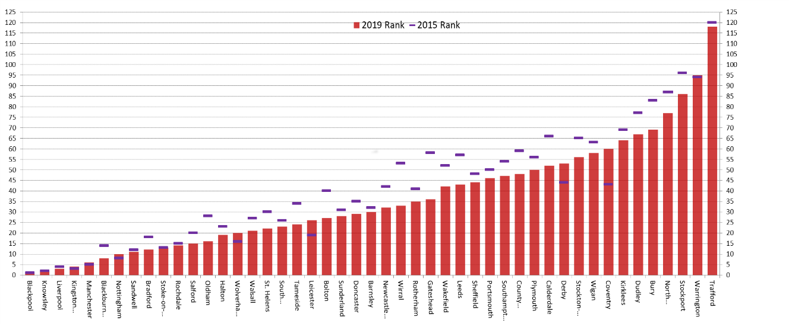
1.6 Whilst this worsening in deprivation ranking is due in part to worse IMD scores of SIGOMA councils, it is also partly due to the improved IMD scores in most other English councils, adding to the “left behind” impact on our members
1.8 As funding for authority services has fallen since 2010, reliance of residents on vital local services has increased due to austerity. There is a strong, pervasive and well documented link between deprivation and the demand for (and cost of delivering) services by local authorities. Our members have worse outcomes in health, education and employment.

1.9 SIGOMA councils, like all upper tier councils, have been held back from the brink of failure by successive one-off adult social care additional funding grants and the ability to raise an adult social care precept. However we are starting from a lower, weaker tax base and generally benefit less from funding which is earned relative to local taxes such as business rates and Council Tax, as is illustrated in later sections. Whilst additional funding is always welcome, a lack of certainty and weak funding base, increasingly unrelated to need, is undermining our services.

1.10 Government has made ‘Levelling Up’ a cornerstone policy of this Parliament with the PM recently renewing his commitment. We therefore hope that our comments and suggestions will be given serious consideration in this Spring Statement.
1.11 We call on Government to stand by its ‘Levelling Up’ manifesto pledge, repeated by the current Prime Minster and show the areas we represent that, though they were foremost in funding cuts during austerity, they will benefit from a national regeneration programme which would benefit the whole country going forward.
- Executive summary

2.1 The relative deprivation of SIGOMA councils has worsened and demand for services increased whilst at the same time funds have been cut at a higher rate than other councils.

  - The overall funding quantum is still inadequate and has been supported by one-off social care grants and the social care precept.

  - A longer-term solution is needed, meaning an adequate funding quantum distributed on a needs basis, guaranteed over the medium term.

  - Although our members recognise the case for some incentives, the focus in funding allocations needs to be on fully funding service needs as the first priority. This should recognise that not all councils can raise the same contributions from local taxation and should ensure that funding will be adequate and proportionate to needs for all councils.

  - Government needs to continue to review the multiplicity of funding streams through which councils are financed. Funding would be more effective in a single place-based budget to local bodies as recommended by the LGA.

  - The Levelling up agenda needs to clear in its purpose, simple to obtain, free from political influence of final decisions and targetted towards areas with the most widespread deprivation issues. This means equality in infrastructure investment but also investing in people by removing the poverty barriers to good health, employment, housing and improving social mobility.

  - Councils who have reserves should not be expected to fund the current crisis from those, they are part of the prudent planning process of councils. Financing funding shortfalls from reserves is a short-term measure destined to create further problems.

- Meeting the country’s needs with adequate funding for services

  - Covid has, over the last two years, served to highlight the services which underpin the fabric of society and which Government must sustain.

  - Covid has exposed the link between care services and the pressure on the wider health service and we believe Government is now embracing a spend-to-save philosophy.

  - Covid, and the previous local government settlements have also highlighted that the pre-existing funding levels for local government overall were inadequate. This is particularly true of Adult and Children’s Social Care. Public health is also emerging as a demand led pressure that is set to remain at high levels in the medium term.

  - It is right that Government have diverted significant amounts of funding into social care and they are to be applauded for that, however there are some factors that cannot be ignored..

- Whilst funding levels for Councils have increased significantly in the last 2 years councils are still significantly in arrears over the long term. Core spending has reduced by 20% in real terms since 2010 (-26% for our members)

- The composition funding since 2013 and the introduction of business rate retention has changed income profiles dramatically, with greater emphasis on raising funds through Council Tax and business rates.

Proportion of council funding by source - Change 2013-14 to 2021-22
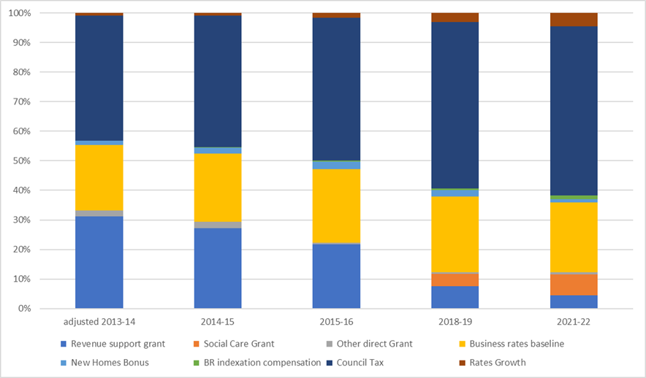
£53.bn*
£49bn*
* Includes rates growth of £409m and an estimated £2,378 million respectively

Without an adequate equalising adjustment, this model will cause and has caused the gap between wealthy and poor authorities to widen. This may create the impression of an overall adequate funding on average, but at council level the picture is different.

  - Record inflation has eaten into recent years’ funding allocations which means that funding intended to enable councils to provide additional capacity to relieve the pressure on the health service now barely allows us to maintain the current post covid standard. Councils have experienced inflation well above the quoted CPI level of 10.5% this year and are facing an increase in the National Minimum Wage of 9.7% in 2023-24, well above the predicted CPI average of 5.5%

  - An early casualty of funding cuts has been preventative spend. As funding falls and demand for services grows, many councils have been forced to abandon spend on preventative measures in order to fulfil their statutory duties. Social care leaders called out the Autumn Statements’ failure to recognise the crisis in children’s’ care exemplified by a 8% increase in referrals to children’s’ social care and 10% rise in the number of child protection enquiries as well as a 2% rise in the children in care population.

  - Similarly, cuts to Public Health funding since its transfer to local authorities represent a direct reduction in one of the more obvious preventative services where reduced funding cannot help but contribute to increased demand for, and cost of, expensive reactive services in health and social care. Public Health funding pressure has of course increased due to covid.

  - In 2010-11 when net business rates base was £19,288 million, core spending power excluding Council Tax was £34,975.

  - In 2021-22 when net business rates stood at £24,863 million, Spending Power excluding Council Tax was £22,681 million.

  - Government must move to further reinstate some of the funding lost in the last in the last 13 years.

- Meeting the country’s needs - Sharing resources fairly

  - Covid has also highlighted the necessity to place scarce funds where they are most needed and the extent to which deprivation and population concentrations can exacerbate the demand for care services.

  - The landscape for local authority funding has changed and any illusion that the country can afford to fund some councils beyond their service needs whilst others fail to provide basic services must be abandoned.

  - Over the last decade, incentivising authority growth has resulted in moving ever-larger amounts of funding away from councils who have the highest need to those who can grow the most resource locally.

  - The real term value of the Core Spending Power in 2010 is £74,052 million and more than 60% of that funding was allocated on a needs basis, either formula based or by matching grant to specific services.

  - By 2023-24, Core Spending Power is down in real terms by 20% at £59,543 million. If estimated rates growth is included, the funding total reduces by 16% to £61,921. Needs distribution now makes up just 37.5% of the funding total, with Council Tax and Incentives making 62.5%, as shown in the table below.

Profile of Core Spending Power 2010-11 to 2023-24
(source as a percentage of the whole) England
Allocation basis | 2010-11  % | 2013-14  % | 2023-24  %
Council Tax | 35.1% | 42.4% | 54.6%
Needs basis | 64.4% | 55.4% | 37.5%
Growth incentive⁷ | 0.1% | 2.1% | 7.8%
Protection of funding | 0% | 0.1% | 0.1%
Other | 0.4% | 0% | 0%

  - It is not difficult to appreciate that the change of emphasis in how funding has been allocated has benefited councils with low needs, a large and growing Council Tax base and a thriving business estate, by comparison to authorities with high needs and relatively low Council Tax and business rate base.

  - This is illustrated by the following two examples taken from an NAO financial sustainability report in 2020⁹.

  - Knowsley Council saw the following changes in income sources
Allocation basis | 2013-14  £m | 2017-18  £m | 2019-20 £m | Change  %
Council Tax | 43.5 | 49.7 | 54.4 | 25%
Business rates | 63.2 | 99.0 | 108.4 | 72%
Gov’t funding | 136.3 | 50.0 | 35.6 | -74%
Other sources | 13.0 | 12.4 | 11.5 | 5%
Total Income | 256.0 | 211.1 | 212.1 | -17%

  - Whilst for Bournemouth, Christchurch & Poole, the change was as follows:
Allocation basis | 2013-14  £m | 2017-18  £m | 2019-20 £m | Change  %
Council Tax | 178.8 | 196.1 | 210.2 | 17%
Business rates | 53.5 | 59.0 | 56.9 | 6%
Gov’t funding | 100.2 | 48.2 | 38.2 | -61%
Other sources | 13.0 | 28.4 | 22.6 | 73%
Total income | 345.5 | 331.7 | 327.9 | -5%

  - Despite having a greater percentage increase in Council Tax and a much higher business rate growth percentage Knowsley’s income fell by a much greater percentage.

  - This is because Knowsley has a much greater dependency on needs funding, which is falling, and can only earn a smaller share of its overall needs from its housing and business rate growth than Bournemouth, Christchurch & Poole.

  - Based on 2021-22 retained growth, we estimate that by comparison to a needs-based allocation our councils lost £150 million of funding with 34 of our 47 councils losing out. Each year that re-set is delayed, poorer councils lose more.

  - This growth above baseline does not appear in Core Spending Power, despite CSP being presented by Government as the “measure of the overall revenue funding available for local authority services”. This in itself is a major deficiency.

  - In addition to the funding imbalance caused by growth incentives, the scheme of rate retention itself has become increasingly complex due to:

- Government interventions in reliefs.
- Government interventions in business rate inflation.
- Changes to the revaluation cycle and interventions in that cycle.
- S31 grants to adjust for all the above and adjustment to those S31 grants.
- Proposed changes to Levy and Safety Net mechanism.
- Disparity between council business rate estimates and outturn.
- Impact of backdated appeals and provisions for those.
- Loss of business rates through academy transfers by schools.
- Further transfers into the central list.
- An un-even playing field created by business rate pilots.
- Delays in promised re-sets.

  - With the future quantum of rate income uncertain and having identified service demand as the main priority, the Government now has the opportunity to simplify government funding by over-riding the rate retention system and rebalancing funding according to need.

  - In our 2015 Policy document “Protecting Vital Services” we put a case for a pooled fund that prioritised service needs but also made provision for incentive payments of the governments design, provided that all needs are funded. We would suggest that the time for such a scheme has arrived.

  - The scheme must take into account the reality of the varying ability of councils to raise funds through Council Tax and business rates.

  - Members support the LGA view, that lots of small, targeted amounts of community funding are not an efficient method of allocating funds. Government needs to stand by its agenda of localising funding decisions.

  - We support the LGA view that there needs to be a consolidation of funding pots, from various Departments and for various purposes, into one place-based grant to provide higher impact and concentrate maximum funding on local issues.

- We call on government to abandon or suspend business rate retention, and the related s31 grants and concentrate funding in to one, readily identifiable funding stream based on needs.

- Funding for growth incentive policies should only be provided after service needs, economic recovery and levelling up are fully funded.

- It is important that additional funding should ensure that no council would lose funding on transition to this approach.

- The Levelling up agenda - Investment

6.1 The Government had made levelling up a cornerstone policy of the current parliament, being frequently referred to in the Queens’ Speech and .the Prime Minister has reemphasised his commitment to levelling up.

  - It has been disappointing then to see the results of the first two rounds of levelling up in which firstly the priority settings, then the bidding process and finally the allocations undermined any sense that Government had a strategy for lifting historically struggling towns and cities onto a par with their more prosperous neighbours.

  - Whilst it is true that every part of the country has its poor areas it is a fact that many parts of the country have a greater concentration of those, as is illustrated in the following map.

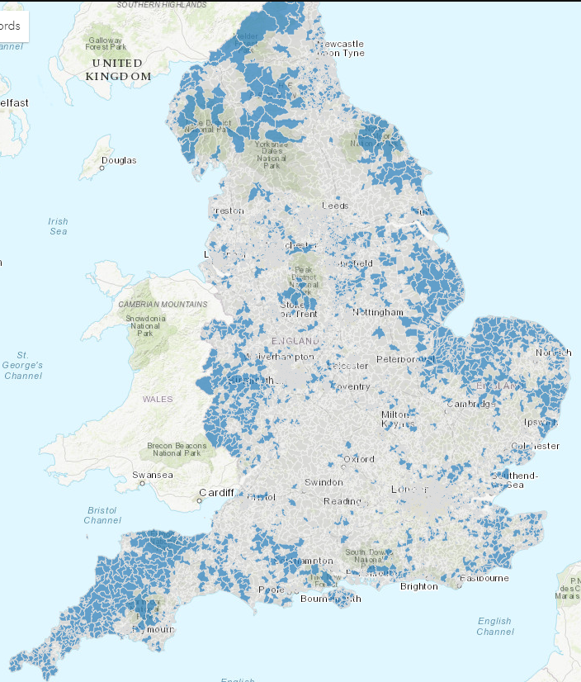
The map opposite shows in dark blue the concentration of Output Areas in the bottom half of the deprivation ranking.

  - Whilst the levelling up fund does tend to favour poorer regions in favour of more prosperous ones it is hardly a reflection of the above map and due to the disparate allocations and bidding process with Ministers as final arbiters, it is unlikely to lead to any regional renaissance.

Regional analysis of Levelling up fund allocations
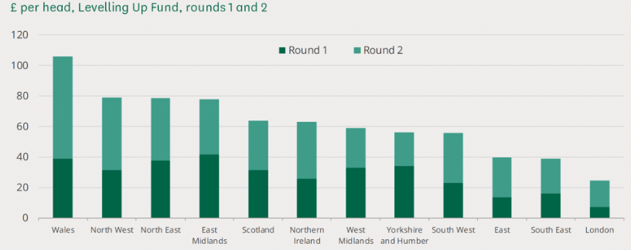

  - Of course the above analysis ignores the lack of funds and wasted effort of the 400+ bids that were unsuccessful in round 2 alone.

- It is vital given the current economic crisis we now face that Government ensures that Levelling up has a greater focus on regenerating more deprived areas.

- An investment programme with ambitions for poorer areas is essential and one in which the levers of decision making are passed into the regions.

- The Levelling up agenda - Equality of opportunity

  - We have argued along with many commentators, that levelling up should not be over focussed on building projects, beloved of politicians.

  - Levelling up must include parity of opportunity. It must, in the words of the former Prime Minister:

…. allow the places that have been left behind to become places that retain their talent, and professionals will be able to stay and bring up their families and enjoy a higher quality of life without the need to move to the supposedly fashionable conurbation.”

  - This means that the health, education and the consequent employment inequalities also need addressing.

  - The health inequalities that accompany deprivation are well documented. Research from the Health Foundation found a direct link between lower income and bad health.

  - Those in the poorest income decile were 5 times more likely to self-report their health as bad or very bad than the top income decile as Chart 7 below shows.

Life Expectancy and Deprivation
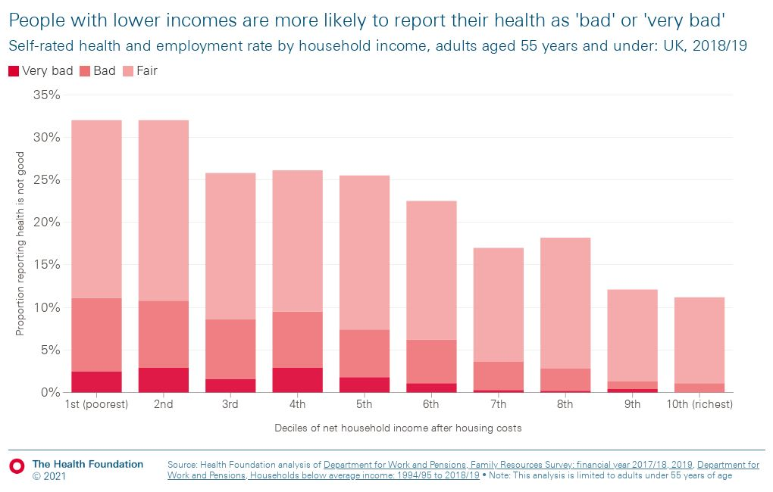

- Use of reserves

  - It is clear that further attention is to be devoted by Government to analysing the reserves that councils hold.

  - Councils hold these reserves as part of their mechanism for responsible financial planning. As an entity that cannot (unlike health trusts) return a negative budget, reserves are a key part of a councils prudent financial planning.

  - It would also be a further step in the wrong direction from devolved responsibility and independence, back towards the assertion that Government-knows-best.

- Therefore, Government is urged to find alternative approaches than constraining council reserves to relieve financial pressures.

- Social Care

  - Government have recently announced a deferral of the Dilnot social care reforms and utilised the funds to stave off a collapse of the adult social care system and the potential related effects on health.

  - We congratulate Government on recognising and beginning a process to address the severe funding problems underlying adult care.

  - The recent announcements provide a buffer against the funding and cost pressures into 2023-24 and 2024-25. However it should be borne in mind that the funds were intended to cover both adult and children’s social care pressures.

  - Inflation has severely undermined the value of the recent grants and if “fair cost of care” remains on Government agenda it is vital that funding is allocated so as to match that.

  - Also, it will be of little comfort to our members to know that their local care cost funding gap is to be financed through placing yet greater burdens on local Council Tax payers, particularly for SIGOMA members given our analysis in section 4 onwards.

  - Councils await news on a plan to solve the problems of social care.

  - The existing social care funding pressures, adults and children’s, must be fully funded at authority level.

- Clear Policy and Direction – What is Local Government For?

  - The expectations of the Government from local government have increased, sometimes in the absence of clear policy or direction from the centre.

  - The time is surely right for a clear understanding between central and local government about what services we are expected deliver, what drives the cost of those services and a mechanism that ensures adequate funding, recognising local tax raising capacity.

  - It is evident more than ever that the payers of tax and the consumers of services are for the most part, not the same people and not necessarily located in the same concentrations everywhere (though an imaginative investment policy could rectify that over time).

  - We need and would work closely with Government to agree:
- A comprehensive policy for caring for the elderly and infirm.
- A proactive service of safeguarding and childcare for those at risk.
- A generous education system that offers equal opportunity across the country.
- A health system aimed at improving health everywhere and eradicating health inequality, not just reacting to illness.
- A national framework of infrastructure improvement and what that should look like post covid.
- Government plans to lift all regions to the same economic status as London and parts of the South and have the country “firing on all cylinders”.

2019 Index of Multiple Deprivation produced by MHCLG, measured in Chart 1 at county level
https://www.communitycare.co.uk/2022/11/17/no-real-recognition-of-childrens-social-care-pressures-in-hunt-statement-warn-leaders/
Adjusted to reflect roll in of CT benefit to CT support grant
From DLUHC data adjusted to include business rates growth
SIGOMA analysis of historic adjusted CSP data and GDP deflators
Growth 23-24 is indicative – unknown at this stage.
2010-11 CT data is adjusted to move CT benefit into “needs”. Treatment of CTB changed n 2013-14 reducing tax base and creating a fixed grant for CT support.
Contains increased rural services delivery grant and transition grant. Removal of negative RSG is not taken into account in this analysis though this is another protection
From data supporting https://www.nao.org.uk/other/financial-sustainability-of-local-authorities-visualisation-update/
Available at: https://www.sigoma.gov.uk/documents/policy-documents?year=2015&id=316
https://commonslibrary.parliament.uk/which-areas-have-benefited-from-the-levelling-up-fund/
From PM speech on levelling up July 2021
Health Foundation, 2020 “Living in poverty was bad for your health before COVID-19”, p.5. Adam Tinson available at: https://www.health.org.uk/sites/default/files/2020-07/Living%20in%20poverty%20was%20bad%20for%20your%20health%20before%20COVID-19.pdf
https://www.health.org.uk/evidence-hub/money-and-resources/income/relationship-between-income-and-health

