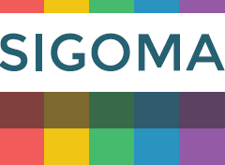
The Special Interest Group of Municipal Authorities (Outside London)
SIGOMA Response to the Provisional Local Government Finance Settlement 2022-23

- About SIGOMA
  - SIGOMA represent metropolitan and unitary authorities outside London, from the Southern Ports, the East Midlands, West Midlands, North West, North East and Yorkshire & Humberside. The 47 SIGOMA Councils are home to 13.8 million people, 24.9% of the English population.

  - We welcome the opportunity to contribute to the consultation but regret that further time could not be allowed for this, given the late release of Settlement information.

  - Our authorities typically represent areas that have suffered most during post-industrial decline; 43 of our 47 authorities are in the lower half of the Deprivation Ranking with 12 of the most deprived decile being SIGOMA members, including the top 4 most deprived.

  - Significantly, our authorities became relatively more deprived in the latest publication of the IMD, due in part to worsening conditions of our members but also due to the relative improving conditions of other authorities, placing us firmly in the “left behind” category referred to by the Prime Minister
Index of Multiple Deprivation – Change in Ranking SIGOMA Members
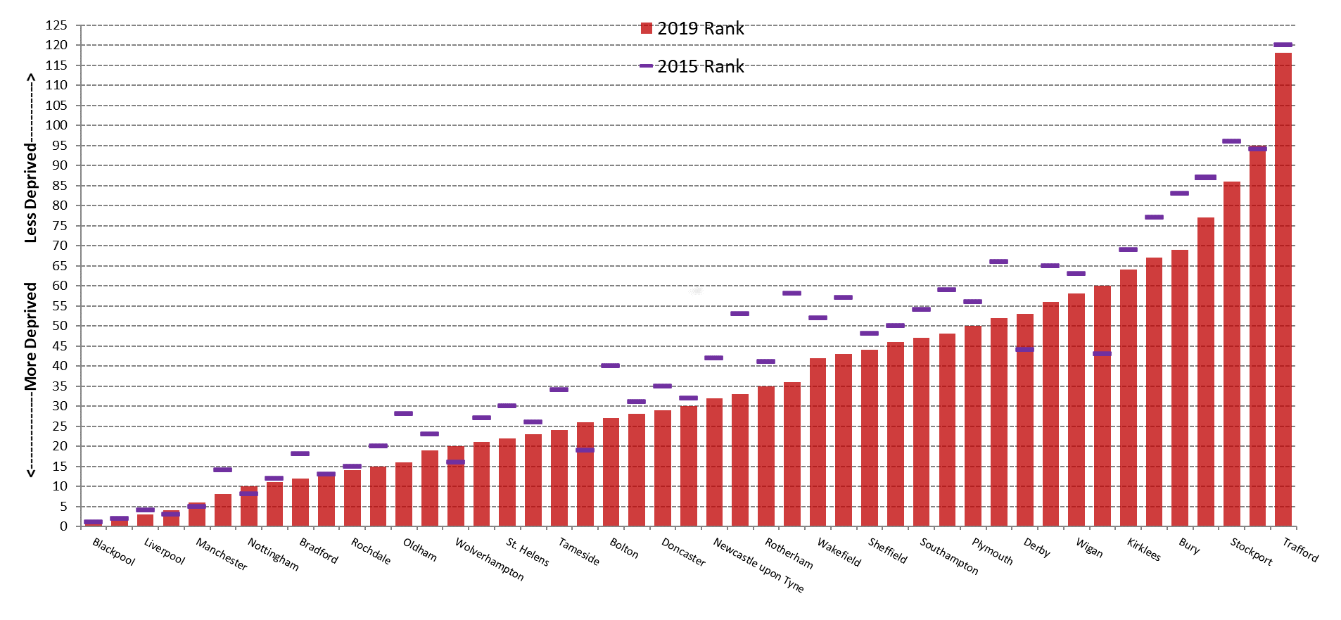

  - Our members have started with high hopes of the Governments levelling up agenda but have been left disappointed with outcomes from of Levelling up Fund and Community Renewal Fund.

  - They welcome the announced change in emphasis of settlement funding by the Minister, away from retaining local tax growth and towards a distribution based on needs and trust this is the beginning of a focus on funding service needs and growth equally across the country.

  - At the same time, we regret the fact that this is only a one-year settlement leaving some uncertainty as to future funding in years beyond 2022-23.

- Question 1: Do you agree with the government’s proposed methodology for the distribution of Revenue Support Grant in 2022/23, including the rolling in of two New Burdens grants?

  - The values in the supporting table do not seem to support the statement in the consultation

i) the government proposes to increase 2021/22 RSG levels in line with the September 2020 to September 2021 change in the Consumer Price Index (CPI)
and
ii) government intends to roll in the Electoral Registration grant worth £1.2 million per year and the Financial Transparency of Local Authority Maintained Schools grant, worth £0.8 million per year, into the Revenue Support Grant.

  - However, the adjusted Revenue Support Grant from the two Key Information tables (incorporating the 50% value of increased retention pilots) appear to show that RSG has increased by 3.1% only and therefore does not include the additional £2 million new burden grants. i.e.

£2,334.1m x 1.031 = £2,406.5m = 2022-23 RSG (with pilots adjusted)

  - Similarly, the combined values for Settlement Funding and compensation for under indexation appear not to support the separate assertions of the settlements statement. Since compensation for business rate under indexation is, provisionally, based on CPI, Tariff and Top up are adjusted by CPI and RSG is uplifted by CPI we expect that the combined value of Settlement funding plus compensation for under indexation would increase by CPI i.e. by 3.1%, when it seems only to increase by 2.9%.

  - We do not agree with the Departments plan to continue the elimination of so-called negative RSG. We would remind Ministers that the purpose of this adjustment was to balance out the different abilities of councils to raise income through Council Tax.

  - This adjustment to RSG has continued whilst Council Tax has risen, unfairly befitting some of the most prosperous councils by at least £153 million, to the disadvantage of others.

  - Council Tax has become by-far the single largest source of Core Spending Power due to grant cuts, rising from 41% of CSP in 2013-14 to 59% in 2022-23, as illustrated by the following chart:
National Audit Office - Change in Core Spending Power 2010-11 to 2020-21
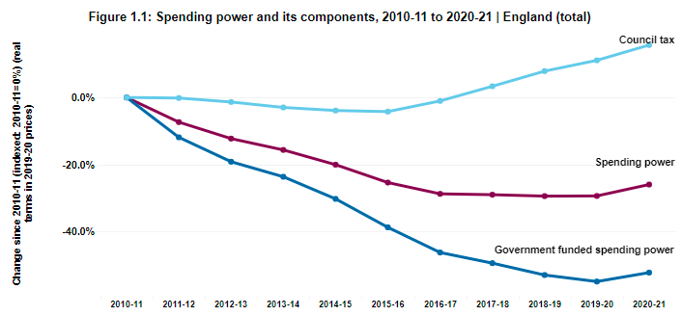

  - Due to this policy our councils, who have lost most from grant funding over the last decade and benefit least from rises in Council Tax, see the gap continuing to widen.

- Question 2: Do you agree with the proposed package of Council Tax referendum principles for 2022-23?

  - Members support the LGA position that if Government truly support independent local government, councils should be left to decide the levels of local taxation.

  - In our answer to question 1, we have made clear the inherent problem of financing the majority of council spending through Council Tax and a failure to recognise the different ability of councils to raise tax.

  - Members wish to make clear that the Council Tax system as it stands makes it inherently more difficult for our members to raise the necessary funds without unduly penalising occupiers of modestly priced dwellings, due to disparities in house values.

  - This is illustrated in the following chart, showing the range of variations in the value of average tax raised per dwelling as a percentage of local Band D taxation, for all billing authorities:
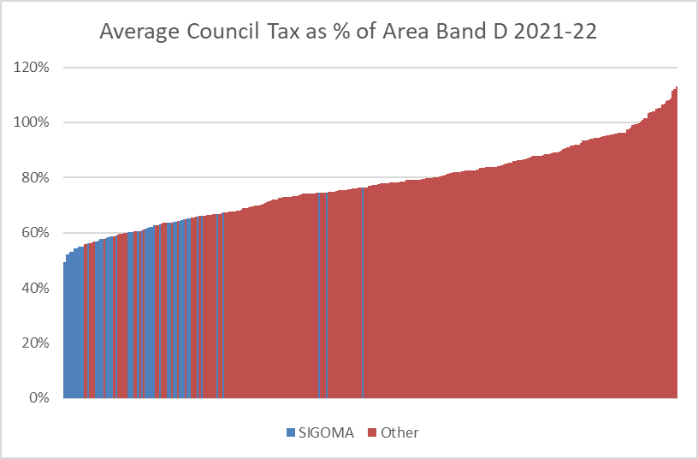

  - So, it can be seen, that each £100 increase in band D tax in the lowest ranking Council, Liverpool, earns less than half the amount in average taxation than the highest, Kensington and Chelsea.

  - For this reason, it is vitally important that differences in Council Tax bases are fully taken into account both in the settlement and the Fair Funding review.

- Question 3: Do you agree with the government’s proposals for the Social Care Grant in 2022/23?

  - For reasons which will hopefully be apparent from the previous sections, we believe a greater portion of the overall grant should be given over to equalisation and question the reason behind the choice of £80 million.

  - Full equalisation with the social care precept would result in a modest redistribution in favour of our members of a total £3.9 million.

  - We welcome that this grant is un-ringfenced but join the LGA in highlighting that this funding will not be sufficient if it is intended to cover the pressures in both adult and children’s services and can only be considered a stop gap in terms of the funding needed for both services.

- Question 4: Do you agree with the government’s proposals for iBCF in 2022/23?

  - Members welcome the inflationary increase whilst pointing out that related costs are increasing at above-inflationary rates whilst service demand is also adding upwards pressures.

  - Latest inflation figures show rising annual CPI and RPI inflation, CPI latest figures are up from 3.1% to 5.1%. We know that many of the cost pressures on authorities in care services, especially fuel, will exceed the average rates.

- Question 5: Do you agree with the government’s proposals for distributing the Market Sustainability and Fair Cost of Care Fund in 2022/23?

  - As the consultation only invites commentary on the distribution basis, we agree that the use of ASC relative needs formula is a reasonable basis

  - There are separate issues about whether the funding would facilitate a significant pay offer for providers or a better care offer, which would require a much bigger financial input.

- Question 6: Do you agree with the government’s proposals for a one-off 2022/23 Services Grant distributed using 2013/14 shares of the Settlement Funding Assessment?

  - Whilst members welcome the additional £822 million funding and the distribution basis for 2022-23, the accompanying statements that this funding is one-year only is a cause of great concern

  - This funding is clearly identified as a “one-off” yet it is also described as including compensation for the increase in National Insurance in order to finance social care.

  - It was made clear during the Departments presentation to the Public Accounts Committee and other presentations that the calculation of the NI recompense excluded salaries of external care providers paid under contract by Councils. As such, this would have led to an under-estimate of the impact of the NI increase on local authority services.

  - Estimates of NI based on direct pay costs only, put the NI/Levy impact at £260-£300 million annually, however when one factors in services provided by 3rd party contractors the pressure could easily be nearer £500 million.

  - Therefore, members question what the intention is for funding the NI impact in years beyond 2022-23

  - We acknowledge that government have stated their intention to engage with the sector on future use of the funds to help transition to Fair Funding We are keen to provide input to that engagement.

- Question 7: Do you agree with the government’s proposals for New Homes Bonus in 2022/23?

  - We have, in the past, objected to the methodology of funding New Homes Bonus by top-slicing from RSG and this objection remains

  - Any proposal that reduces the topslice is therefore welcome, though we note that the disregard within the calculation remains as a blanket 0.4% when this should be tailored to the average growth history of the authority.

- Question 8: Do you agree with the government’s proposals for the Rural Services Delivery Grant in 2022/23?

  - We continue to object to the arbitrary and unsupported nature of this grant.

  - The funding would be more appropriately added to RSG where it would be distributed according to need formula, which includes a sparsity weighting.

- Question 9: Do you agree with the government’s proposals for the Lower Tier Services Grant, with an updated minimum funding floor in 2022/23 so that no authority sees an annual reduction in core spending power?

  - Members recognise the objective of ensuring no cash-terms reduction in spending power and generally support the focus on core spending power impact as an aim, whilst wondering why this had not been the focus in previous years.

  - Members are also of the view that retained growth in business rates (at 50%retention) should be taken at least partially into account in measuring movement in spending power.

  - The additional £1.4 billion of funds represented by growth is now a significantly distorting factor when comparing funding and spending power between authorities. With a re-set date still further down the horizon it is time that rates growth was at least factored into the relative funding increases/decreases being experienced by authorities when considering grant top ups.

- Question 10: Do you have any comments on the impact of the proposals for the 2022/23 settlement outlined in this consultation document on persons who share a protected characteristic, and on the draft policy impact statement published alongside the consultation document?

  - For the reasons outlined above we consider that the Settlement has made a welcome shift towards funding the most needy.

  - We also acknowledge the difficulties caused by Covid. Indeed, we would point to the covid experience to highlight the over-riding need to fund essential care services adequately and in proportion to service demand, recognising the impact of deprivation.

  - However, this settlement still leaves vulnerable children and adults exposed in two principal ways

- By failing to recognise or attempting to measure the quantum of funding needed to keep pace with the cost of providing decent care for vulnerable adults and children.

- By perpetuating the allocation of local authority funding according to growth in Council Tax and business rates rather than a needs-based assessment

2013-14 Core Spending Power tables DLUHC
The Index of Multiple Deprivation 2019 as published by MHCLG

