

*The Special Interest Group of Municipal Authorities (Outside London)*

**SIGOMA Response to the Provisional Local Government Finance Settlement 2019-20**

1. **About SIGOMA**
   1. SIGOMA represent metropolitan and unitary authorities outside London, from the Southern Ports, the East Midlands, West Midlands, North West, North East and Yorkshire & Humberside. The 47 SIGOMA Councils are home to 13.8 million people, 24.9% of the English population.
   2. We welcome the opportunity to contribute to the consultation but regret that further time could not be allowed for this, given the much later than planned release of settlement information.
   3. Our authorities typically represent areas that have suffered most during post-industrial decline; 42 of our 47 authorities are on the lower half of the Deprivation Ranking[1] with 10 of the most deprived decile (15 authorities) being SIGOMA members, including the first 5 most deprived.
   4. Our members are caught between pressures from increasing demand due to personal-welfare policy decisions and the worst effects of successive settlements since the austerity programme began.
   5. Despite assurances from successive Ministers that “we are all in this together” our authorities feel that the measuring stick of who is worst affected by austerity measures changes to suit policy, to the benefit of those who are more affluent. Few residents in SIGOMA authorities would acknowledge that this settlement supports our Prime Minister’s assertion that they should “know that austerity is coming to an end”.
2. **Question 1 Do you agree with the methodology for allocating revenue support grant in 2019-20?**
   1. Government’s published measure of changes in funding is Core Spending Power. The settlement cites a real term increase in CSP in 2018-19. Those same statistics show a real term reduction in spending power since 2010 of 24.5% and, within that, a cut to our members of 30.9%.
   2. Yet, as our submission will show, the Minister choses the abstract notion of negative RSG to decide who is most in need of additional funding.
   3. Since the RSG methodology must be taken to incorporate the decision to eliminate negative RSG in the manner described in the technical consultation, we cannot agree with it.
   4. As the Department has reminded us on more than one occasion, a significant majority of authorities agreed to the proposed 4 year offer made in December 2015. This offer included:

• Revenue Support Grant;

• Business rates tariff and top-up payments;

• Rural Services Delivery Grant;

* 1. The Minister can hopefully understand our frustration with the latest proposals on removal of negative RSG when considering the results of this and all other changes to CSP between the original and the latest settlement for 2019-20.
  2. The result of injecting additional funding for transition and negative RSG has been to maintain the imbalance between SIGOMA and other authorities. This is illustrated in the following table comparing changes in SIGOMA and non SIGOMA Core Spending Power over the 4 year offer period firstly, as originally proposed, and now with this latest proposal.



* 1. The negative real terms impact is calculated using in the Governments own calculations using GDP deflators, however Government will be aware that authorities have actually suffered inflationary pressures above CPI due to the impact of the national living wage and now the latest proposals for changes to local government pension reform, suggested by the local government pension scheme advisory board, which could add an estimated further 0.9% to authority payroll costs and will take effect from 2019-20.
  2. In addition, MHCLGs information presented on Core Spending Power is misleading in that it includes the department’s own projection of retained business rates rather than actual business rate earnings.
  3. MHCLGS own data showed that in 2016-17 there was a wide variation between the amount of settlement funding implied in the core spending power figures and the amount actually earned, increasing the funding gap between authorities.

The following box plot shows our estimates of variation in settlement funding if NNDR1s are used rather than Government SFA estimates.

Authority level variations – “actual” Settlement Funding to CSP illustration

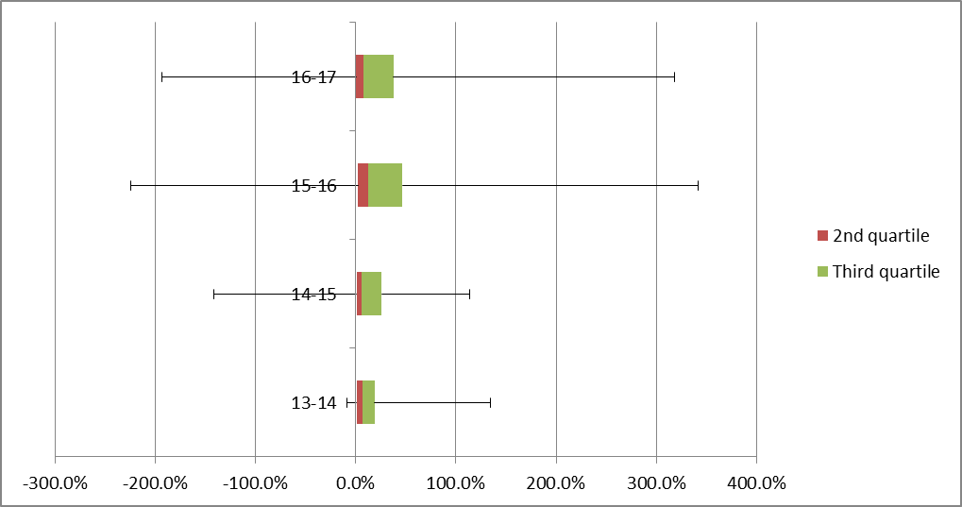

Derived from MHCLG tables on NNDR returns and incorporating S31 compensation

* 1. We share the disappointment of most of our colleagues that the Department is unable to give even an indicative value for overall local government funding beyond 1 April 2020. With no spending review imminent, Councils face the prospect of funding for the following year remaining unknown until December 2019.
  2. We suggest that the Department reappraises its plans for RSG in light of those worst affected in terms of Core Spending Power, not RSG reduction.

1. **Question 2: Do you agree with the Government’s proposed approach to allocating £410 million un ringfenced funding for adult social and children’s social care according to the existing Adult Social Care Relative Needs Formula**
   1. Additional funds allocated on a needs basis will always be welcome.
   2. The accompanying statement, that this funding covers both adult and children’s care pressures, however, seems aimed more towards members of the public or national press. Local authorities must view the announcement in context of the size of service costs.
   3. Children’s services including other education services is currently budgeted at £11,441 million per annum whilst adult social care is budgeted at £16,119 million, a total of £27,560 million. Therefore the additional funding represents additional one-off funding of 1.5 pence for every £1 of council spend.
   4. Of course, authorities will also be able to charge additional Council Tax via the Social Care precept but this will benefit some authorities more than others, as not all Council Tax bases are the same, as is illustrated in section 7.3 below.
   5. We would recommend that the allocation should take into account the ability to raise local funding via the precept but otherwise accept it as a reasonable approximation given the relatively small amount of funds.
2. **Question 3: Do you agree with the Governments Proposal to fund the new Homes Bonus in 19-20 with the planned £900 million from Revenue Support Grant?**
   1. Members do not agree that the NHB should be funded in this way as it removes much needed resource funding from the most deprived authorities to reward some of the most affluent.
3. **Question 4: Do you agree with the Government’s proposed approach to paying £81 million Rural Services Delivery Grant in 2019-20 to the upper quartile of local authorities based on the super sparsity indicator?**
   1. Our members have no objection to distributions based on objective evidence based calculations of need, and therefore cannot support the rural services grant.
   2. MHCLG’s own independently commissioned research showed that rurality was more likely to lead to lower costs than to higher ones in the majority of circumstances.[2]
   3. As with the removal of negative RSG and extended transition grant. The Government has acted against the initial recommendations of the Department and the Government’s own four year offer, to contribute to a settlement and fair funding proposal that has lost credibility with many of our members.
4. **Question 5: The Government intends to distribute £180 million of levy account surplus. Do you agree with the proposal to make this distribution on the basis of each authority’s 2013-14 settlement funding assessment?**
   1. We agree with the proposal.
   2. There has been comment from members that the practice of over top-slicing and then returning funds at short notice is not conducive to effective budgeting and planning and can lead to authorities cutting services which would otherwise have been sustained.
   3. The issue has raised concerns amongst members regarding the business rates consultation. The full cost of safety net should be financed from levy on excessive growth, not top-sliced from settlement funding allocations.
5. **Question 6: What are your views on the Council Tax referendum principles proposed by the Government for 2019-20?**
   1. We support the LGA in their submission that authorities should not be subject to referenda on Council Tax.
   2. We would also comment that using Council Tax increases to resolve specific funding issues will, if not matched by equalisation measures, widen imbalances between needs and funding.
   3. The following table shows, for example, the variation in the impact of a 3% Council Tax increase as a percentage of each authority Core Spending Power.

Average 1.75%

* 1. Councils would also benefit from an understanding of what is planned for Council Tax beyond 2020.

1. **Question 7: What are your views on the Government’s approach to tariffs and top-ups in 2019-20?**
   1. We have already made the position of our members regarding the adjustment of “negative RSG” clear in the answer to question1, whether this is taken to be part of RSG adjustment or the top-up and tariff adjustment our points on negative RSG apply to both these questions. See sections 2.2 to 2.7 above.
   2. SIGOMA has participated in the working group discussions on the issue of top-ups and tariffs following revaluation. Under the circumstances this is accepted as the best practicable method of adjustment.
   3. Some SIGOMA members still feel that they have been disadvantaged by the overall adjustment methodology at revaluation which did not take account of changes in value of hereditaments with reliefs which ran contrary to the changes in value of other hereditaments. This was particularly the case for authorities with university and college hereditaments.
   4. Many members have had difficulty in tracking the changes in tariffs and top ups and changes to s31 compensation as a result of cap compensation, emphasising the increasing complexity of the business rate system which it is hoped will be resolved by changes to the business rate system.
2. **Question 8: Do you have any comments on the impact of the 2019-20 local government finance settlement on those who share a protected characteristic, and on the draft equality statement published alongside this consultation document? Please provide supporting evidence.**
   1. It is our view that the funding mechanism, including this settlement is likely to contribute to wide variations in the level of service that can be offered to the poor, elderly disabled and disadvantaged individuals in many of our communities.
   2. MHCLG has now clearly stated that its policy of assessing the likelihood of an authority financial failure is assessing funding against an authority’s statutory duties.
   3. This may leave many authorities, even authorities who are not yet “at risk”, unable to invest in pro-active preventative measures to assist those most in need.
   4. Many preventative services and early interventions are non-statutory. These services help to keep demand for crisis services under control.
   5. Therefore, only ensuring authorities have sufficient resources to provide statutory services is not a sustainable approach. Without vital non-statutory services demand will increase at a faster rate than it otherwise would have and councils will in time become unable to fulfil their statutory obligations to the standards residents expect.

1. The Index of Multiple Deprivation 2015 as published by MHCLG
2. “Of the 51 expenditure groups considered, sparsity was found to be positively and significantly related to unit costs in 11 cases. These services accounted for £7.0bn (or 15.0%) of local authorities’ total expenditure in 2012/13. Sparsity was significantly and negatively associated with unit costs in 15 cases. These expenditure groups accounted for £14.6bn (or 31.1%) of total expenditure in 2012/13. In the remaining 25 cases, sparsity was not found to have a statistically significant effect on unit costs. These groups accounted for £25.3bn (or 53.9%) of total expenditure.” [LG Futures (Dec 2014) DCLG/DEFRA Research into Drivers of Service Costs in Rural Areas p4](https://assets.publishing.service.gov.uk/government/uploads/system/uploads/attachment_data/file/388595/Rural_main_report.pdf)