Consultation Response
About SIGOMA (the Special Interest Group of Municipal Authorities)
SIGOMA represents 47 English Councils in Metropolitan Districts and Unitary Authorities around the Country. Typically our councils represent areas that have been the subject of post industrial and maritime decline and face some of the most demanding economic and demographic challenges.
This also applies in relation to Child welfare services and demand for high needs provision. SIGOMA share of the under 17 population has remained static at around 25.4% since 2013, whilst its share of Children in need has crept up by fractions of a percentage point each year and now stands at 31.1%.
Children in Need 2021
 | U17  Population No. | % Of Total | Children  in Need No. | % Of  Total
SIGOMA | 3,068,841 | 25.3% | 211,415 | 31.1%
Non SIGOMA | 9,024,449 | 74.6% | 467,928 | 68.9%
England | 12,093,290 |  | 679,343

Children’s services statistics show that the number of children in need has risen marginally but steadily in our authorities up to 2021. Officers in the service are bracing themselves for a surge in post-pandemic numbers.
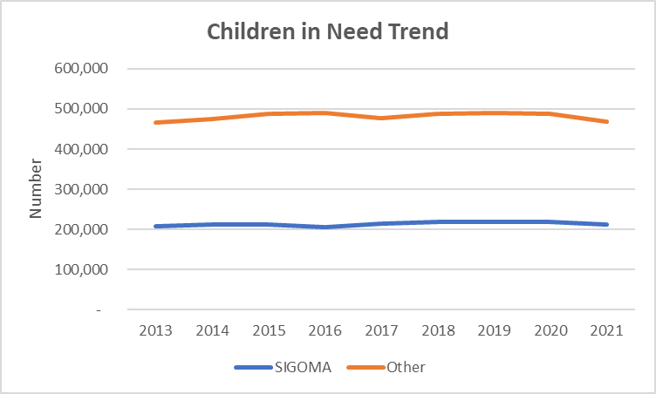

Like all other councils, our councils also have seen a disproportionate growth in the proportion of their student populations receiving SEN support or with a Statement of needs or EHC plan, around a 19% increase in numbers between 2015-16 and 2021-22. Again our share of SEN pupils with SEN as a proportion of the pupil population remains significantly higher than the national average.

Proportion of Pupils with SEN or EHCP
 | Pupil  Population | Students with  SEN or EHCP | Share of  Pop. %
SIGOMA | 2,226,655 | 385,512 | 17.3%
Others | 6,191,358 | 989,233 | 16.0%
National | 8,418,013 | 1,374,745 | 16.3%

In terms of expenditure, poorer municipal authorities have faced the greatest challenges of all in terms of funding cuts since 2010-11.

As the following NAO data shows, this has been reflected in the very difficult decisions our members have faced and we wonder if the Department has a broad enough perspective on how our members have been challenged and how this has already been reflected in spending decisions including those in SEND.

National Audit Office – Real Terms Spending changes 2010-11 to 2019-20

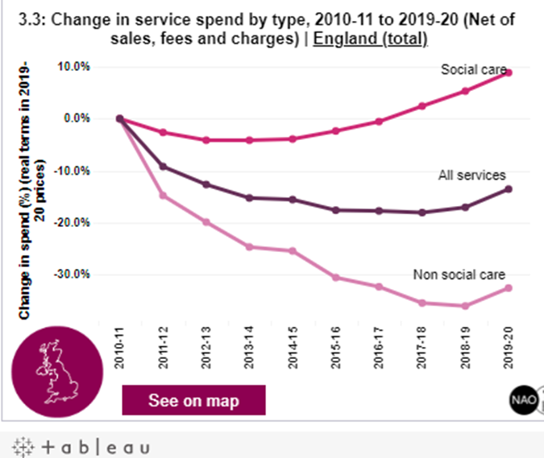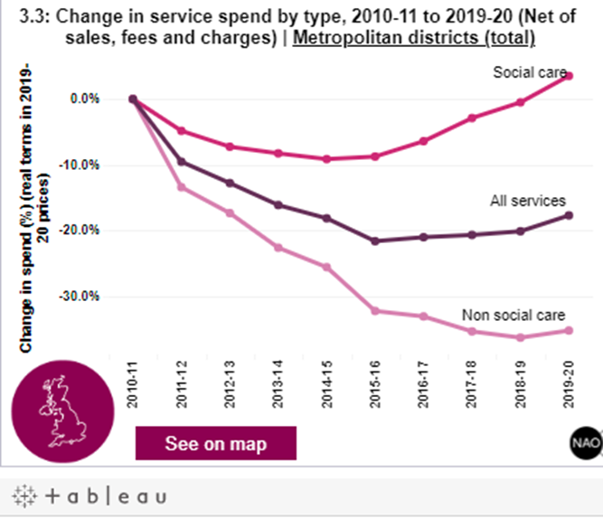

The graph shows that service spending in England fell by 13.6% over the period. Social services were maintained at an 8.9% real terms increase by cuts in other services of 32.6%. Metropolitan districts outside London, service spending fell by 17.7%. They could only sustain a 3.5% (less than half the national average) increase in Social Services and even then sustained a 35.2% cut in other services despite the fact that they faced the greatest increase in demand led pressures on social care.

Response to the Consultation

General
Our members broadly welcome the service changes being proposed by the green
Paper, as did the Association of Directors of Children’s Services. Like them, we look forward to further development of the suggested changes. In expanding this development the Department should have consideration for:

- The varying levels of access to alternative provision across the country
- The standard or baselines of such provision and its cost
- The standards required for SEN provision in mainstream schools
- The time needed to transition to the proposals

Q18.How can we best develop a national framework for funding bands and tariffs to
achieve our objectives and mitigate unintended consequences and risks?
The department has already referred to the work done by councils in this area and therefore development should be undertaken in close consultation with Councils and the LGA. The Department should recognise that Councils occasionally have to react in real-time to placement issues, therefore there should be flexibility when placements have to be made during the year. Any proposed structure should be publicised well in advance (at least a year) so that the market available to each council can be established.
Q22.Is there anything else you would like to say about the proposals in the green
paper?
During the consultation period the DfE have published Guidance to local authorities “Sustainability in high needs systems”
https://assets.publishing.service.gov.uk/government/uploads/system/uploads/attachment_data/file/1084835/Local_authority_guidance_on_high_needs_sustainability.pdf

This refers to the fact that DLUHC will remove the statutory override that allows councils to maintain a negative High Needs element of their DSG reserve from 2023-24.
An increasing number of Councils have shown negative DSG reserves over the last 5 years
Aggregate of negative DSG Reserve Values
Year | £ million | Number  Of Councils
2021-22 (e) | -845 | 72*
2020-21 | -742 | 70
2019-20 | -506 | 73
2018-19 | -233 | 52
2017-18 | -155 | 43
* of which SIGOMA members are 20
A recent survey conducted by our colleagues n the Society of County Treasurers (in which our members participated) concluded that high needs expenditure is significantly outpacing income. They projected that by March 2025 the national high needs deficit could reach £3.59 billion.
Whilst officers accept that the Department are making welcome moves towards addressing high needs they conclude that;
- Funding of high needs should increase both to cover future funding and help councils (particularly those who do not have access to the same levels of council tax and business rates as others) both with expected demand and accumulated arrears.

- The statutory over-ride should be continued until the Department has helped all councils towards a non-deficit position

From Childrens services statistics: https://explore-education-statistics.service.gov.uk/find-statistics/characteristics-of-children-in-need/2021#dataDownloads-1
From - https://www.gov.uk/government/statistics/special-educational-needs-in-england-january-2022
https://www.nao.org.uk/other/financial-sustainability-of-local-authorities-visualisation-update/
The charts compare England to Met districts, the nearest comparison to our members (who include some of the most deprived unitaries) provided by NAO data.

