Local Authority Financing. A Briefing for Members of Parliament

Local authority funding has been transformed since 2010, both in terms of a severe cut to the funding available to deliver services and in the way in which that funding has been allocated.

Some of the changes that we proposed in our 2015 policy document “Protecting Vital Services” have been implemented, though many aspects of local government funding still give cause for concern and some of the negative outcomes we envisioned in that document have become a reality.

This document analyses the changes and their implications for local government, for SIGOMA authorities and for Manchester City Council.

Cuts 2010 to 2016

Changes in local government funding streams have obscured the true reduction over the six year period. Using Government’s own measure of “Core Spending Power” however, it can be seen from the chart below that local government has undergone a sustained and significant reduction in total funding up to recent times.

Annual core spending power and cumulative percentage cut to English authorities
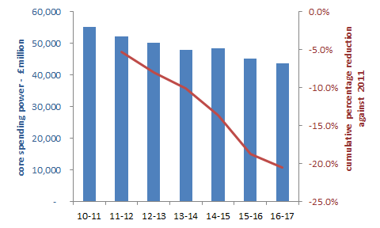

This accumulates up to an overall real term fall in core funding of £11.9 billion, equating to an average real term cut of £221 per head of population or a 20.5% fall over the 6 years since the first austerity budget of 2010.

Disturbing though the above figures are, the cuts have not been borne evenly across the country, with some authorities bearing a much higher burden of cuts than the national average. SIGOMA authorities are amongst the worst affected by the unequal distribution of cuts.

For SIGOMA authorities the cuts have been harsher and earlier. The fall has been over £300 per head or 27.4%, over the same period.

Cumulative percentage cuts – England and SIGOMA average
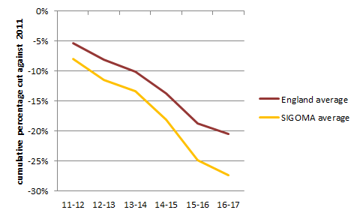

A comparison for Manchester shows an overall reduction in core spending power of 33.2%.This is 12.7% worse than the England average.

Annual core spending power and cumulative percentage cut Manchester
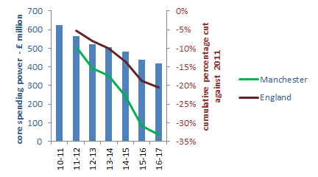

The stark regional variations, split along lines of poverty and deprivation, are illustrated in the heat map of real term cuts per head, on the following page.

Here we see that urban areas have carried the greatest burden of cuts per head since 2010 with the worst affected falling in some of the most deprived areas of the country.

Real Term Cuts - £ Per Head at 2016 Prices

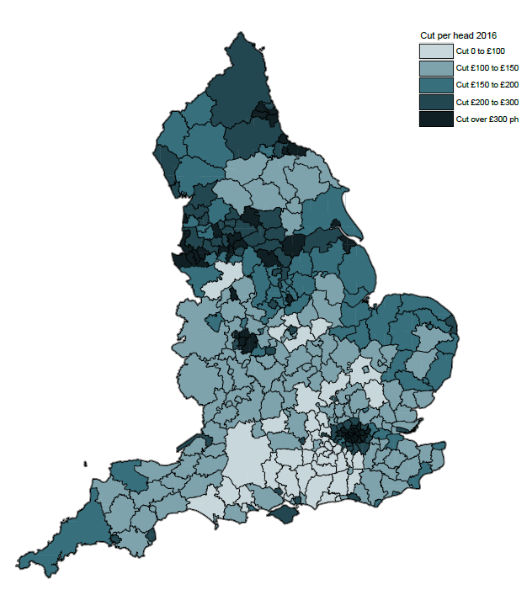

© Crown copyright and database rights (2013) Ordnance Survey licence number 100022264
The map calculates the real term value of cuts, at 2016 prices, at district level. The distribution of cuts per head closely matches estimates in our 2013 “Fair future” document, though the values are worse than the predictions in our document.

Changes in expenditure profiles

Needless to say, such dramatic funding changes have resulted in diminishing expenditure by authorities. The following table shows the change, in core service expenditure between 2010-11 and 2015-16, for SIGOMA authorities, compared to all other English authorities.

The profile of change is similar for most authorities; it shows protection of children’s and adult social care services resulting in higher cuts to other services. But overall, and in each individual aspect of service expenditure, SIGOMA authorities have been forced to cut further and faster than other English authorities. The result is an overall cash terms cut of 5% for all other authorities compared to a cut of 13% for SIGOMA councils!

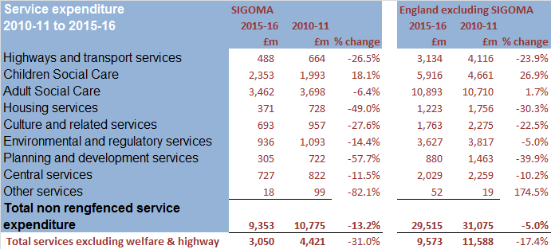
Extracted from DCLG Revenue outturn tables. Excludes fire and rescue authorities and funding taken on by combined authorities.

For Manchester the overall impact is a cut of 27.4%, which is 22.4% worse than the non-SIGOMA average.

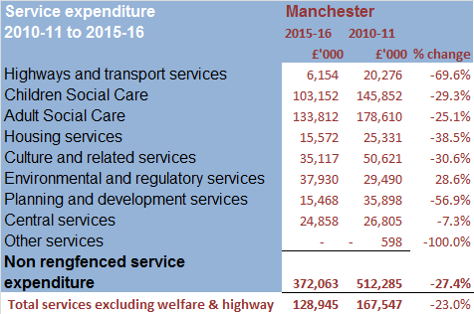

Demand for Services

If expenditure on services has declined, the same cannot be said to be true of demand. Comparing the change in the IMD, suggests that concentrations of deprivation have increased or remained the same in 13 out of the 20 most deprived authorities (which includes 12 SIGOMA authorities).

Many SIGOMA authorities have jumped up the deprivation ranking. Since 2010, 26 out of 46 of our authorities were worse by an average 8 places, whilst 6 of the 10 most deprived authorities in the country are SIGOMA members, compared to 5 out of 10 in 2010.

Manchester has moved from 4th most deprived to 5th most deprived authority in the country.

Poorer residents will look to local government to assist with their day to day existence, whilst poverty is a strong indicator of increased reliance on services such as adult and children’s social care.

Hence for example in England the number of looked after children in authorities has increased by an average 9.3% to 70,440 between 2010 and 2016. This represents an increase from an average 57 looked after children per 10,000 in 2010 to 60 per 10,000 in 2016.

This average increase is higher for SIGOMA authorities, up 10.8%, and the average number of looked after children per 10,000 is higher, up from 80 to 83.

For Manchester the number of looked after children decreased by 13.3% and from 137 to 105 per 10,000 over the last 6 years.

Cost of Services

Independent of the demographic changes, there is an ongoing upward pressure on authority costs due to central government fiscal initiatives. These included:

- Setting a new higher National Living Wage.
From 2016-17 the NLW was increased by 7.5% to £7.20 per hour. The previous Government’s objective was to have a NLW at 60% of median earnings by 2020, equating to over £9 per hour on current values, an increase of over 33% over the 4 year period.

A survey of our members suggested that, even at optimistic estimates of impact, costs would rise by over £4m million per council per annum in 2017-18 as a result of NLW, representing an increase of around 7% of net adult social care costs of 2015-16.

- Abolishing the contracted out rate of employers National Insurance.
This increased the cost of employment by 3.4% at a stroke and will compound any increases due to NLW and annual pay increases. Authorities are unable to mitigate this by amending LA pension scheme contributions.

Both of these factors will raise costs of services for authorities above normal inflationary pressures, even if though this may be indirectly through provider contracts.

It is already emerging that services such as adult and children’s social care in particular will see their projected costs increase as a result of these factors, above normal inflationary increases.

Decreased funding, increased cost pressures and worsening demographic trends are combining to create a funding gap of unsustainable proportions. This must seem obvious, yet disturbingly, in 2014 the National Audit Office reported that:

“[DCLG] has a limited understanding of the financial sustainability of local authorities and the extent to which they may be at risk of financial failure”.

The same report also stated that:

“Authorities that depend most on Government grants have been affected
most by Government funding reductions and reforms”.

Self-Financing - Business Rates and Council Tax

The previous administration placed great emphasis on self financing for local government. Whilst this seems a plausible ideal, the current state of individual authorities and regions must be recognised. There are widespread mismatches between local populations (which in turn drive demand for services) and locally raised income.

For example, at the time that 50% local retention of business rates was introduced, 43% of total retained rates went to London and the South East, who together represented only 32% of the English population.

By contrast the combined business rates of East Midlands, West Midlands and the North West represented just 26% of 2013 total business rates, yet those regions also represent 32% of population.

This disparity has continued and widened by 2015-16, with London and the South East retaining 44% of national business rates whilst the Midlands and North West retained 26%.

The chart on the following page illustrates the imbalance of the proportion of retained rates in 2016 compared to the proportion of population at 2013.

At a regional level it shows that the business rate share of London dwarfs that of other regions and that London is the only region where rate share exceeds the population share.

Manchester’s share of national business rates in 2016 is also shown, against the right hand axis, as 1.38% whilst its share of the 2013 national population was 0.95%.

Share of 2016 Retained Business Rates and Share of 2013 Population
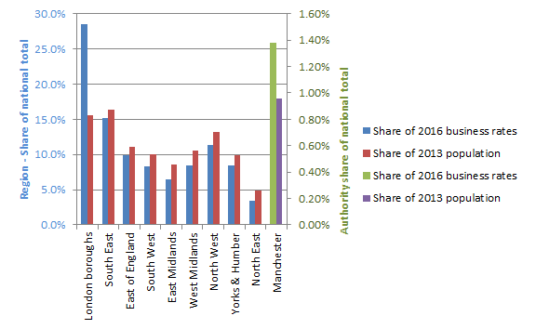
Business rate shares for London boroughs include 9.2% of total rates collected for the Greater London Authority which performs functions not financed from business rates in other regions.

The wide variation in rate income is also illustrated in the following graph, showing business rate income per head of population across individual authority types.

The predominance of London authorities at the high end can be seen, particularly Westminster who are off the scale at £1,978 per head. 38 out of the 46 SIGOMA unitary and metropolitan authorities are below the national average of £218. Manchester's retained rates of £316 per head of population are separately highlighted.

2016 Retained Business Rates - £ per head of population at County Level
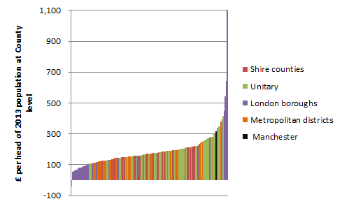

Under the current 50% retention mechanism, the impact of this disparity is balanced out through an equalising adjustment known as “Top up and Tariff” which adjusts rate income to match needs. It is also balanced by capping retention of excessive business rate growth and losses.

The current proposals for 100% rate retention are to remove caps on retention of rate growth, leaving less for authority needs and widening the gap between better and worse off authorities over time.

The picture on Council Tax is the same, with a wide disparity in the ability of councils to finance services out of locally raised Council Tax.

The following chart shows Council Tax per head of population across authority types from the lowest tax per head, Wandsworth at £164 per head to the highest, City of London, at £745 per head⁻¹⁰.

It can be seen that metropolitan districts feature prominently in the lower half of the scale, whilst 45 out of 46 unitary and metropolitan authorities represented by SIGOMA are below the national average of £432. Manchester’s Council Tax per head of population, shown in the chart, is £265 which is £167 below the national average.

2016 Council Tax - £ per head of population 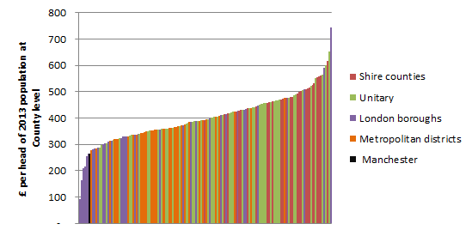

Combining the two income streams of Council Tax and business rates into one “per head” total underscores the different challenges facing our authorities across the country.

The data illustrated in the following chart, shows that the highest decile in the graph earn on average double the amount per head than that of the lowest decile.

The low tax raising capacity of SIGOMA authorities is also shown in the chart, highlighting the relatively low tax raising potential of our members, with 44 out of our 46 members having combined earnings below the national average of £650 per head.

The chart highlights the place of Manchester's combined income per head of £581.

2016 Council Tax and Retained Business Rates - £ per head of population 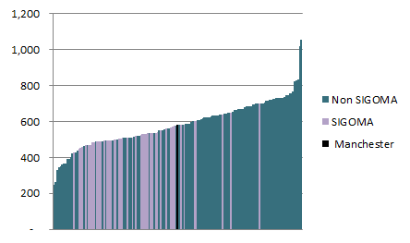

Future Funding

Following the publication of our policy document, recommendations from the Public Accounts Committee for improvements and representations from ourselves, the LGA and other stakeholders, there has been a move towards moderation by Government in respect of local authority funding cuts, this has included.

- In December 2015, publication of a “multi year settlement offer” to authorities, proposing a settlement covering the years 2016-17 to 2019-20, unlike the usual two year settlement. This provided some of the certainty in funding that we and others requested.

- In 2015, the introduction of an “Improved Better Care Fund”, rising from a £105 million total in 2017-18 to £1,500 million in 2019-20. This provided a back loaded fund aimed specifically at adult social care.

- In 2015 the introduction of a social care precept. This gave social care authorities the opportunity to raise Council Tax by a further 2% above the usual 2% referendum cap aimed specifically at financing social care expenditure.

- In 2015 a change in the way cuts to Revenue Support Grant were apportioned which took some account of the differing sizes of Council Tax base in councils, something that SIGOMA has raised in the past.

- In 2015 an announcement of the Government’s intention to consult on 100% retention of business rates by Councils. This included a request for local authority volunteers to pilot 100% retention schemes. At the same time DCLG instigated a consultation on the needs formula that underlies settlement allocations.

- In 2016 final settlement, a one-off 2017-18 adult social care support grant of £241 million.

- In 2017 Budget, an addition to the “Improved Better Care fund” of £2,021 million; of which £1,010 million will fall in 2017-18, £674 million in 2018-19 and £337 million in 2019-20. Again this is aimed exclusively at councils with adult social care responsibility.

Taking into account all of the above initiatives, the national profile of core spending power to 2019-20 is as follows:

England core spending power 2015-16 to projected 2019-20
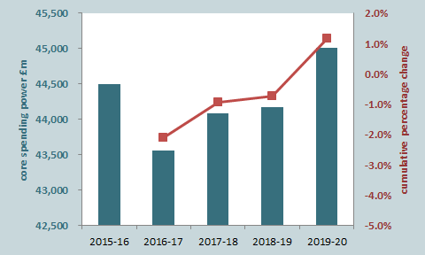

This shows a cash terms increase in core spending power of 1.2% over the spending review period.

This change in emphasis has made some difference but despite this SIGOMA members are still playing catch up with other authorities, showing a cash terms increase of just 0.2% over the spending review period, one sixth that of the national average increase.

SIGOMA core spending power 2015-16 to projected 2019-20
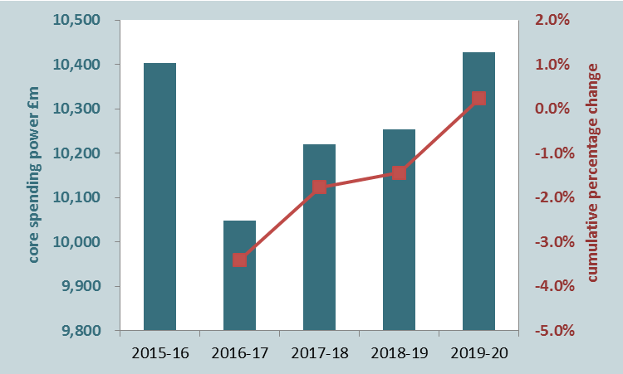

The core spending power of Manchester will increase by 0.1% in cash terms over the spending review period, 1.1% below the national increase.

Manchester core spending power 2015-16 to projected 2019-20 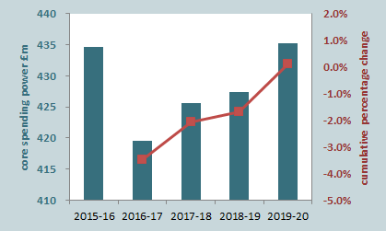

It should be noted that these figures are presented in cash terms. According to Governments’ own RPI estimates, funding would have to increase by 13.4% over the review period to maintain services at 2016 levels (yet council costs are increasing at above RPI levels). Therefore the above figures represent a national real-terms cut of 12.2% and a real-terms cut to SIGOMA of 13.2%. The real-terms cut to Manchester is 13.3%.

In addition, the core spending power estimates of DCLG assume that all authorities will grow their Council Tax base at historic levels and maintain their business rate base. This is by no means certain for all authorities.

Ongoing issues with funding allocations

As we have said, there have been some improvements in recent years in the way funding is allocated; but there is still an underlying tendency to support historic allocations to more prosperous authorities, which becomes increasingly untenable as overall funding decreases.

- Part of the reason that our authorities are failing to catch up is a reluctance by Government to adhere to the formulas it has set out to devise a fair and logical allocation of funds.

- The underlying needs formula still includes a damping element to limit the reduction to wealthier authorities.

- When re-defining RSG cuts in 2016, Government tinkered with the results that generated negative RSG for certain prosperous authorities.

- Government created a transition grant to mitigate cuts to some authorities which, by focussing solely on RSG, ignored the wider funding streams available to authorities.

- Although the 2015 RSG reduction methodology did take account of Council Tax income for the first time since 2013, it used a fixed measure for this, rather than taking account of Council Tax growth.

- Government continue to uplift rural services grant without any clear methodology or justification for doing this.

- Government continue the practice of Top Slicing i.e. reducing overall funding before applying formula, in order to finance incentive schemes such as New Homes Bonus and business rate retention.

SIGOMA programme for the next parliament

- SIGOMA will continue to represent our members interests in the steering and working groups formed by Government and the LGA.

- We will provide members with analyses of Government proposals and regulations.

- We will respond on members’ behalf to future consultations on matters affecting them.

- We will hold meetings of MPs, Members and Officers of authorities we represent, to discuss matters of interest and potential actions.

- We will raise matters of interest to our members through letters to Ministers and senior civil servants as well as comments and articles to the press and in social media.

- We will form coalitions, where appropriate with other organisations who share our views and concerns.

Our Core Principles

Our core principles were set out in our document “Protecting Vital Services”. They are:

Fairness: People in similar circumstances pay the same price for receiving the same service outcome i.e. equalisation of resources and ability to pay.

Providing Incentives for Growth and Innovation: Without impacting on total resource for funding core services.

Promoting Local Democracy: Local accountability for the provision of services that the local community demands.

Independent determination: The system, once agreed, should be free from party political interference.

Our Message for the New Administration

We will be calling on Government to:

- Prioritise the protection of vital services, at their true cost, in funding allocations.

- End the practice of top-slicing needs allocations to fund growth retention and other incentives.

- Support forward planning by advance notice of funding allocations.

- Set up a clear and transparent funding system. A move away from centrally negotiated settlements based on a central agenda.

- Relax restrictions on local revenue raising by elected officials.

- Introduce an independent body to oversee central funding allocations.

- Prioritise needs and efficiency above rewarding growth.

The Special Interest Group of Municipal Authorities
(outside London) within the LGA
PO Box 14
Town Hall Barnsley
Telephone 01226773101
Email enquires@sigoma.gov.uk
www.sigoma.gov.uk

http://www.sigoma.gov.uk/__documents/public/Protecting-Vital-Services.pdf
Business rates, Council Tax, improved better care fund, new homes bonus and rural services grant.
The annual % cut is by comparison to an adjusted prior year, calculated by DCLG
http://www.sigoma.gov.uk/__documents/public/A-Fair-Future.pdf
i.e. excluding education and public health, which are financed from ringfenced budgets.
The English Index of Multiple Deprivation published by DCLG. Measured on a collection of indices, scored and ranked at authority level, where 1 is the most deprived. Measures were made in 2010 and 2015 on a comparable basis
https://www.nao.org.uk/wp-content/uploads/2014/11/Financial-sustainability-of-local-authorities-20141.pdf_this view was endorsed by the Public Accounts Committee in 2015.
Business Rates of districts added to their counties, rates of GLA shown as one authority at £158ph. Chart excludes City of London £35,636ph.Westminster Council is £1,978 ph. Extracted from 2016-17 NNDR1 and includes estimated S31 SBRR compensation.
Extracted from DCLG core spending power tables with fire authorities and GLA adjusted.
Council Tax of districts added to their counties, CT of GLA shown as one authority at £92 ph. Extracted from 2016-17 Core Spending Power Tables and using 2013 estimated mid-term populations.
Income of GLA shown as one authority at £250ph. Excludes outliers of Scilly isles £1,068, Westminster £2,194 and City of London £36,380
Retail Price Index, the measurement of annual inflationary increases in costs
Revenue Support Grant The main formula based funding allocation to authorities which now bears total cuts to funding and inflationary increases in Business Rate income.

